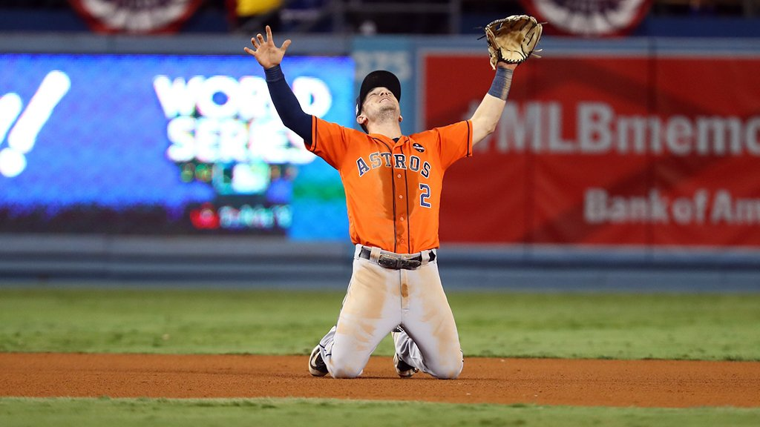**Alex Bregman Career Trajectory Projection**

By Joshua Goldberg

*Overview Information*

* In evaluating of Alex Bregman’s MLB trajectory, I focused on predicting his WRC+ over the rest of his career
* Following Bill James’ calculator to determine number of MLB seasons left, I estimated Bregman to have nine years remaining in his Major League career, according to his formula and evaluating for Alex, we get: [42 – (23: Bregman’s current age)] / 2 = 9.5; However, as he turns 24 at the end of March, his year total is closer to 9 than it is to 10 currently
* To forecast statistics throughout Bregman’s MLB career, I located his MLB metrics and utilized Baseball Reference’s Similarity Score by Age to identify nine of the most similar MLB athletes who had played in the MLB they were between 24 - 32 years old (based on performance in career up to age 24), which correspond to the next nine years of Alex’s expected career
* These nine other players included: Jim Thome, Danny Tartabull, Edwin Encarnación, Tony Perez, José Guillén, Chase Headley, Willie Jones, Gary Gaetti, and Tim Wallach
* Why did I choose to focus on WRC Plus? Because of all the factors involved in determining WRC+, the metric is an excellent way to measure a player’s offensive output, especially based on the impact of park location, and additional league adjustments

**SCATTERPLOT ANALYSIS**

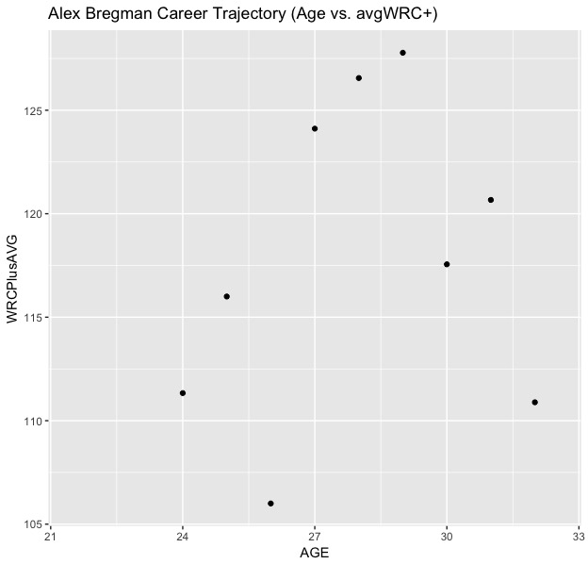

* In the Scatterplot on the left, I performed a statistical analysis to see the average WRC+ value for each age year from 24 – 32 for the nine other MLB players I evaluated in this project
* While the average WRC+ value increases between 24-25 years old, it drops at age 26, which could be an outlier point, as the average WRC+ value then increases again to near 125, where it increases for three years in a row – including Bregman’s predicted best WRC+ year, at age 29
* Between age 29 - 32, Alex’s projected WRC yearly total fluctuates back and forth before eventually falling to a total near his age 24-year WRC+ total
* In a linear model to predict avgWRC+, the factor with the greatest predictive power was avgwOBA, with a correlation total of almost 0.90
* Additionally, in collecting the data for my research, I found the data on Fangraphs and Baseball Reference, organizing the data in Excel before cleaning it in R, through several steps, including re-identifying data columns as numeric and vice-versa for character data
* When building my model to determine WRC+ for Alex during his projected next eight years of his career, I looked at predictors strongly connected with offensive production, including wOBA, OBP, Batting Average, and SLG (%)